RODDRECUS CHAMES  Military Veteran | Secret Security Clearance  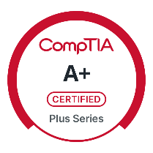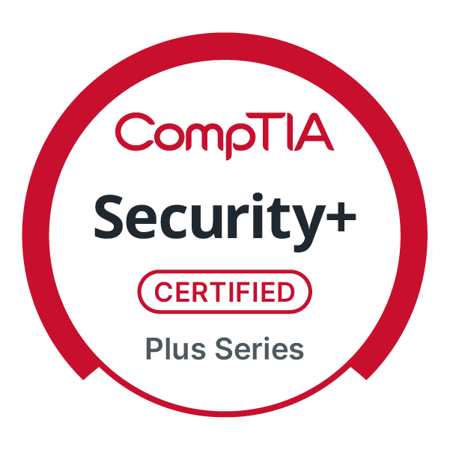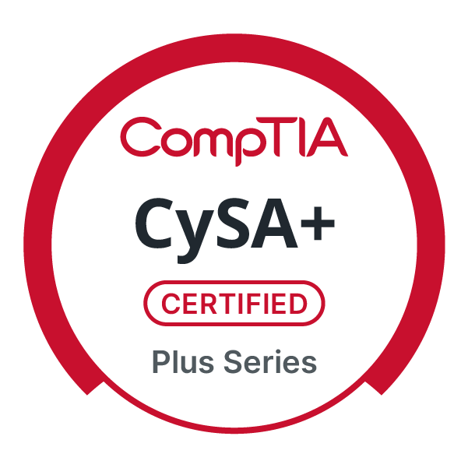 | rod.chames@gmail.com  https://www.linkedin.com/in/rodchames/  205-383-9876  Virginia Beach, VA, 23464, USA  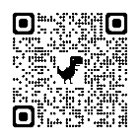
 | RODCHAMES.COM

I’m a U.S. military veteran currently working as a Service Desk Analyst on the Navy Marine Corps Intranet (NMCI), where I provide secure technical support and help enforce cybersecurity standards across one of the largest enterprise networks in the world. My goal is to become a SOC Analyst, and I’m actively building that by completing hands-on labs focused on ethical hacking, threat detection, and network defense. I bring a mission-driven mindset, a passion for cybersecurity, and a growing portfolio that reflects my commitment to continuous learning and helping others break into the field.

WORK EXPERIENCE
Service Desk Analyst (NMCI)
SAIC | Norfolk, VA May 2025 – Present
- Acted in a systems administrator capacity by managing Active Directory accounts, troubleshooting GPO issues, and provisioning secure workstations for NMCI users; supported an average of 20 users per day with a 18-minute average handling time, ensuring secure and compliant system access across a global DoD enterprise.
- Conducted triage and resolution of security-related incidents including account lockouts, system anomalies, and failed login attempts, escalating potential indicators of compromise (IOCs) to Tier II and III teams.
- Executed 1,000+ PowerShell scripts monthly to automate secure workstation configuration, enforce access controls, and remediate vulnerabilities in compliance with DISA STIGs and Zero Trust principles.
- Supported patch verification, vulnerability remediation, and configuration rollback testing to harden endpoints and reduce exposure in a globally distributed infrastructure.

Media Specialist Jan 2024 - Mar 2025
Old Dominion University | Norfolk, VA.

- Managed team of four photographers and videographers in delivering multimedia solutions for 33 units, supporting a student body of 24,000 students, yielding an increase in social media engagement by 19%.
- Directed multimedia production for college communications, boosting digital engagement by 125% and video viewership by 200% within one year.
- Spearheaded strategic content initiatives that increased social media impressions by 45% and campus event attendance by 60% through innovative video and photography campaigns.

SYSTEMS ADMINISTRATOR (ASM) Sep 2018 - Feb 2024
United States Navy | Norfolk, VA.

- Deployed and configured remote ASM servers during transitions from airfield to ship deployments, achieving full operational capability within 4 hours of arrival and supporting mission-critical applications with 99% uptime.
- Managed 382 user accounts in Active Directory and ASM, maintaining a 100% audit compliance rate and provisioning or deprovisioning accounts within 30 minutes on average.
- Liaised with CSFWL ASM Systems Administrators to resolve 60+ cross‑domain issues per year, cutting escalation resolution time by 40% and preventing mission delays.
- Maintained personnel records for 235 members in SQL databases, ensuring 100% accuracy in qualifications tracking and enabling rapid verification during readiness inspections.
- Generated 50 readiness and compliance reports monthly, automating data pulls and reducing reporting errors by 15% through standardized SQL queries and PowerShell scripts.
- Coordinated 40 annual training schedules, collaborating with stakeholders to achieve a 98% on‑time certification completion rate and improving overall personnel readiness.
- Troubleshot and resolved 25 ASM server incidents annually, ranging from OS failures to network misconfigurations, reducing server downtime by 30% and maintaining 99% service availability.

IT Help Desk Support Mar 2014 - Sep 2018
United States Navy | Norfolk, VA.

- Trained 13 personnel to deploy and maintain 72 computer systems, ensuring compliance with DoD standards.
- Ensured 100% compliance for a department of 150+ users by conducting monthly audits of computer usage policies and remediating 25+ non‑compliant configurations per quarter.
- Created and provisioned 200+ user accounts (Active Directory, email, VPN) annually, maintaining a 99% accuracy rate and reducing onboarding time by 30%.
- Logged and tracked 1,200+ help‑desk tickets per year in ServiceNow, achieving an average first‑response time of 20 minutes and resolution time of 4 hours.
- Troubleshot and resolved 500+ hardware and network issues, including printer, VPN, and Wi‑Fi outages, maintaining 98% uptime for critical systems.
- Staffed daily policy‑compliance watches, reviewing 300+ user sessions weekly to identify and escalate 15+ policy violations, leading to targeted user training that reduced repeat offenses by 40%.
- Managed and updated the department’s SharePoint site with 50+ new documents and workflows annually, improving information accessibility and reducing internal email inquiries by 25%.
- Collaborated with cross‑functional teams to implement computer‑usage standard updates, coordinating 4 major policy rollouts per year and delivering 3 training sessions to 150+ staff with 95% positive feedback.

PROJECTS

BamBOOTech Labs Mar 2025 - Present
Home Lab | Virginia Beach, VA.

Created in March 2025, BamBOOTech Labs showcases beginner-friendly IT labs, coding, networking, and cybersecurity projects to help others like me get noticed by recruiters while learning and growing my IT skillset. YouTube: https://youtu.be/c_h5_ZG6J0Y

TryHackme.com Member Nov 2024 - Present
Home Lab | Virginia Beach, VA.

I use TryHackMe to gain hands-on cybersecurity experience with real-world tools like Nmap, Wireshark, Splunk, and Metasploit in safe, simulated labs.

- Scanned and mapped 500+ network targets using Nmap, Gobuster, and TCPdump, uncovering hidden services and reducing reconnaissance time by 40%.
- Brute‑forced 128+ credentials across SSH and HTTP(S) with Hydra and John the Ripper, achieving a 15% credential recovery rate to test defensive posture.
- Parsed and normalized Windows Event Logs, Linux syslogs, and Virtualization hypervisor logs into a SIEM (Splunk/ELK), ingesting over 20 million events per week with an average MTTD of 10 minutes.
- Developed 20+ Sigma rules and Splunk correlation searches for IDS/IPS and Threat Hunting, cutting false positives by 35% and surfacing 50+ high‑severity alerts monthly.
- Analyzed 1200+ packet captures with Wireshark, TCPdump, and Zeek (via REMnux), detecting lateral movement and data exfiltration techniques in under 30 minutes per capture.
- Encrypted and decrypted simulated data streams using Cryptography libraries in Python and CyberChef, ensuring proper handling of TLS, SSH, and VPN traffic during incident investigations.
- Automated enrichment workflows with Python scripts and PowerShell, integrating MISP, OpenCTI, and CAPA to ingest 1,500+ IOCs, improving analyst efficiency by 50%.
- Conducted full‑stack penetration testing using Metasploit, Burp Suite, SQLmap, and OWASP Top 10 techniques against Linux and Windows AD targets, documenting 25+ exploitable findings and driving remediation.
- Simulated advanced adversary tactics across the Kill Chain, leveraging TOR Browser, FlareVM, and Exploitation Research labs to validate SOC playbooks and raise incident response readiness from 70% to 92%.
- Built interactive dashboards in Kibana and Splunk, visualizing CSS/HTML/JavaScript–based web application attack patterns, SOC metrics, and Threat Hunting insights, improving reporting cadence by 30%.
- Delivered virtual and in‑person customer service–style incident briefings to stakeholders, explaining complex findings from CAPA, REMnux, and Linode–hosted labs in clear, actionable terms.

CORE SKILLS

Hard Skills & Tools Used:
Offensive Security | Nmap | Hydra
Defensive Security | Cryptography | Gobuster
Linux Fundamentals | Metasploit | SOC Fundamentals
Windows & Active Directory | Exploitation Research | IDS/IPS Fundamentals
Command Line | Penetration Testing | CyberChef
Windows Powershell | Burp Suite | CAPA
Linux Shells | OWASP Top 10 | FlareVM
Networking | HTML | Virtualization
TLS, SSH, VPN | CSS | Azure
Wireshark | Javascript | Linode
Tcpdump | Python | TOR Browser
John the Ripper | SQL Map | Customer Service
Cryptography | REMnux | Windows Operating System
SIEM | Kill Chain Analysis | Threat Hunting
Network Troubleshooting | Hardware Troubleshooting | Microsoft Office

Soft Skills:
Leadership | Adaptability | Discipline
Teamwork | Effective Communication | Problem-Solving
Time Management | Attention to Detail | Proactive

EDUCATION

Old Dominion University Jan 2024 - Dec 2026
Bachelor of Science Information Systems and Technology

O2O Syracuse University D’Aniello Institute for Vets Apr 2025 - Jul 2025
Career Skills Program CompTIA CySA+ Certification

University of Phoenix Mar 2012 - May 2014
Associate of Arts General Studies

CERTIFICATIONS

CompTIA CySA+ Jul 2025
CompTIA

CompTIA Security+ Mar 2025
CompTIA

CompTIA A+ Certification Jan 2025
CompTIA

Network and Network Security: Connect and Protect Dec 2024
Coursera

Assets Threats and Vulnerabilities Dec 2024
Coursera

Pre Security Dec 2024
Tryhackme.com

